Content Management System
The Content Management System is a web portal system which manages the content of the customer website. Customer can purchase a module for managing their content. Each customer will be provided with their own content area and only privileged user can view their relevant content. All the contents are created, uploaded, published and maintained by the Portal Administrator.

The Content Management System is segregated as modules. Each module will have 3 classifications
- Content
- Multiple Choice Question (MCQ)
- Survey
Each customer should own at least one module. Each module will be tied with individual customer and the modules cannot be shared across. Maximum of two Portal Administrator access will be provided to the customer who has the privilege to maintain users to that module.

- Customer passes the content to the Portal Administrator through mail or personally through the CD
- Portal Administrator creates the module tagged for the customer
- Portal Administrator creates and publishes the content
- Portal Administrator creates the User Administrator for this module
- User Administrator creates the number of users allotted for him who can access the content
- Users who have the privilege for that content can access the module

Customer can subscribe the CMS for particular period of time. Once the content is published for the first time, the expiry date for that module will be assigned. Alert message will be send to the Portal Administrator and User Administrator. Customer can renew the subscription which updates the expiry date
Content Access
Portal administrator creates, uploads and publishes the content. Portal Administrator has the full rights to the content whereby he/she can access all the contents across all the modules. Once the contents are published, portal administrator will create user administrator for the respective company.

User administrator creates and manages the user. User administrator can restrict the users from viewing certain contents. User administrator doesn’t have the privilege to create, modify, upload and publish the content. Both users and user administrator can only view the content. Any changes to the content should go through the portal administrator.
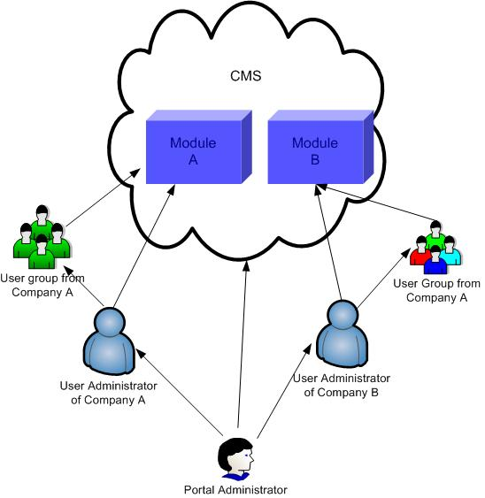

Content Format
The content can be in the below format
- Html
- PDF
- Word
- Excel
- Power point
- XML
- Video files
Based on the need of the customer, the content’s like PDF, word, excel etc can be made non-downloadable format. It can be read or watched only through the CMS web portal.

Content Creation
The customer will provide the raw content to the Portal Administrator through mail or personally through CD. The Portal Administrator will create the content with the standard format using the Content Management System. The content can be created in 2 ways. One with other tools and can upload as file. Two with the Content Creation screen in the CMS.
Once the content is created, the Portal Administrator can preview the page to check whether the content is properly created. The contents created are tagged with the particular customer and the module.

Content Editing
Portal Administrator can edit the content using the Content Management System using Content Edit Manager Screen. Edit Manager screen is provided with WYSIWYG Editor (What You See Is What You Get) which is a powerful tool provides spell check, formatting the alignment and fonts. The editor has drag-and-drop facility for the ease of the portal administrator.

Content Publishing
Until the content is published, it cannot be viewed by User Administrator and Users. Once the content is published by the Portal Administrator, the content will be available to the User Administrator and Users. All the users and user administrator will have only read only permission to the content. Any changes will go through the portal administrator.

File Manager
File Manager lists down all the files, folder structure for a particular customer. Portal administrator can maintain all the files and folders using the File Manager screen. This screen help to copy, update, delete any folder and file. Along with the file and folder name file manager shows the updated date, version of the file and whether the file is published or not.

Versioning
Versioning of the content is maintained in unique way which helps the customer to compare between the versions. When the portal administrator updates the content, the previous content goes to archive and will not be deleted unless it is deleted purposely.

Metadata
Content Management System allows adding and removing the metadata for the contents. This stores the title, keywords and description of the content.

Content Usage Manager
Content usage manager calculates the percentage of content has read by the user. This helps in generating the usage report. This can also tie up with the MCQ and Survey whereby the user has to complete certain number of percentage to take up the MCQ and Survey. The usage report can be accessed by the User Administrator for all the users in his module. Portal Manager can access the report for all the customers. User can view their usage report.

Search Engine
Search Engine allows searching the content quickly and easily. Search indexes the content and define which parts of the content are searching and how the search results are displayed. Certain keywords are used in the content which helps to search the content quickly.

